Device Token

📱 What Is a Device Token?
# Source: Chatgpt (GPT-5-Mini) at [1/20/2026]
A Device Token is a unique identifier assigned to a specific user device (like a phone, tablet, or browser) by a server or notification service. It's most commonly used to send push notifications to that device or to identify the device in backend systems.

✅ Simple Definition:
# Source: Chatgpt (GPT-5-Mini) at [1/20/2026]
A Device Token tells the backend which device to talk to, especially for things like push notifications or session tracking.

🔄 Where You’ll See Device Tokens
# Source: Chatgpt (GPT-5-Mini) at [1/20/2026]
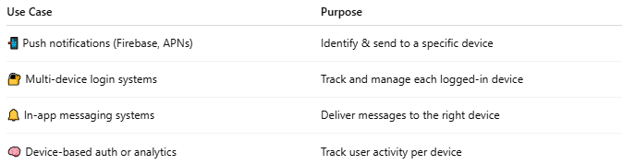

Use Case | Purpose
📲 Push notifications (Firebase, APNs) | Identify & send to a specific device
🔐 Multi-device login systems | Track and manage each logged-in device
🔔 In-app messaging systems | Deliver messages to the right device
🧠 Device-based auth or analytics | Track user activity per device

📦 Example (iOS / Android Firebase Token)
# Source: Chatgpt (GPT-5-Mini) at [1/20/2026]
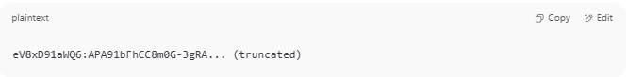
eV8xD91aWQ6:APA91bFhCC8m0G-3gRA... (truncated)

📮 Push Notification Flow (Using Device Token)
# Source: Chatgpt (GPT-5-Mini) at [1/20/2026]
- User opens your app
- App registers with a notification service (e.g., Firebase or Apple APNs)
- Service returns a device token
- Your app sends this token to your backend
- Your server stores the token per user
- When you want to send a notification:
  - Your server sends a message + token to the push provider (e.g., Firebase)
  - The provider delivers the notification to that exact device

🔐 Security & Management Tips
# Source: Chatgpt (GPT-5-Mini) at [1/20/2026]
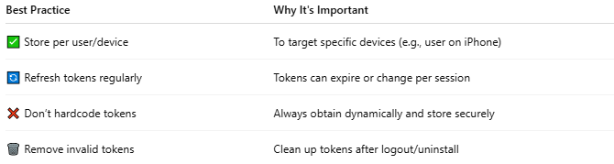

Best Practice | Why It's Important
✅ Store per user/device | To target specific devices (e.g., user on iPhone)
🔄 Refresh tokens regularly | Tokens can expire or change per session
❌ Don’t hardcode tokens | Always obtain dynamically and store securely
🗑️ Remove invalid tokens | Clean up tokens after logout/uninstall

🔄 Device Token vs Session Token
# Source: Chatgpt (GPT-5-Mini) at [1/20/2026]
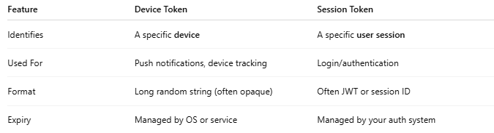

Feature | Device Token | Session Token
Identifies | A specific device | A specific user session
Used For | Push notifications, device tracking | Login/authentication
Format | Long random string (often opaque) | Often JWT or session ID
Expiry | Managed by OS or service | Managed by your auth system

📌 Summary
# Source: Chatgpt (GPT-5-Mini) at [1/20/2026]


Field | Value
Purpose | Identify and send data to a specific device
Format | Long random string (token)
Common Use | Push notifications, per-device tracking
Managed by | Firebase, APNs, or your app backend

